Tutorial 03.

1. A queue is a linear data structure that follows the First In, First Out (FIFO) principle. It is an ordered collection of elements where insertion occurs at one end, commonly known as the "rear" or "tail" of the queue, and removal occurs at the other end, known as the "front" or "head" of the queue. The first element added to the queue is the first one to be removed. Queues are used in various computing applications, such as process scheduling, task management, and breadth-first search algorithms.

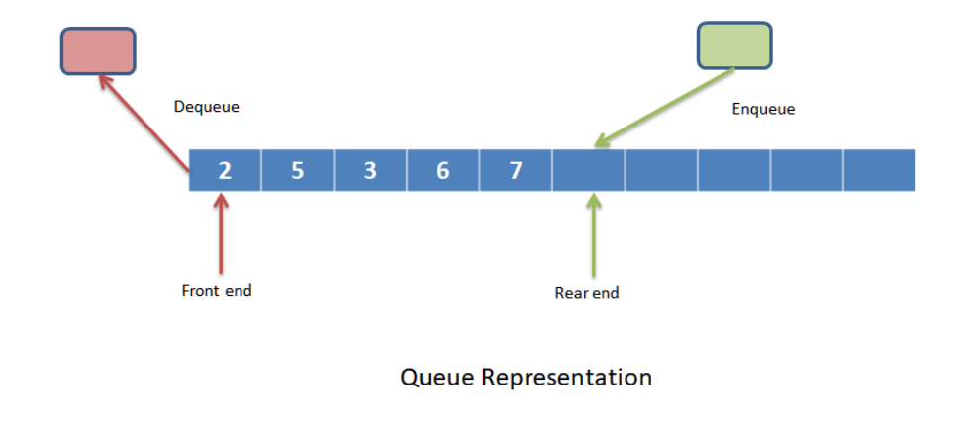



FIFO (First In, First Out) Order

Enqueue (Addition)

Dequeue (Removal)

Peek (Front Element Access)

Empty Queue Detection

Size Determination

1. FIFO stands for "First In, First Out" and refers to the principle of processing or serving elements in the order of their arrival. The first element to enter the system is the first one to be processed or removed, maintaining the original order of insertion. This concept is commonly applied in queues and is essential in various computing applications for fairness and proper task management.

1. - Initial Empty Queue: The queue is empty when it is first created, and no elements have been added yet.

- After Dequeue Operations: When all elements in the queue have been removed.

(dequeued), the queue becomes empty.

- Explicit Check: When you explicitly check the queue to see if it is empty using an "is

empty" or "empty ()" function, it may return true if there are no elements in the queue.



Supermarket Checkout Queue

ATM Queue

Bus Stop Queue

Traffic Queue

Print Queue

Customer Service Queue

Restaurant Waiting Queue